WDF Practical-01
Sitemap & Wireframe
Pranshu Gandhi
25dit017
01st Aug, 2026

Sitemap
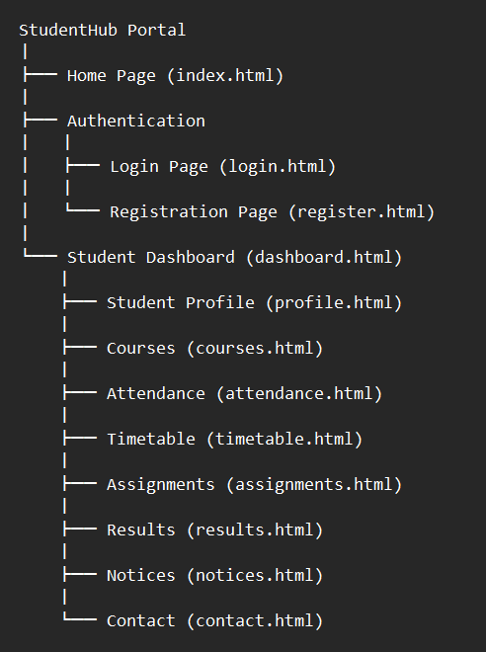

Purpose of Sitemap:
Sitemap is created to represent the structure and navigation flow of a website before development.
It helps developers understand:
- How pages are connected.
- How users move from one page to another.
- What pages are required in the project.

StudentHub Navigation Flow:

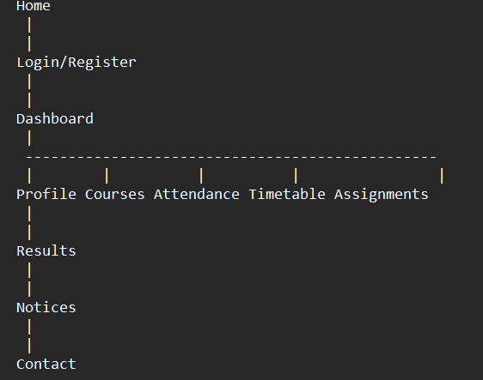

Low Fidelity Wireframes

PAGE 1: HOME PAGE (index.html)
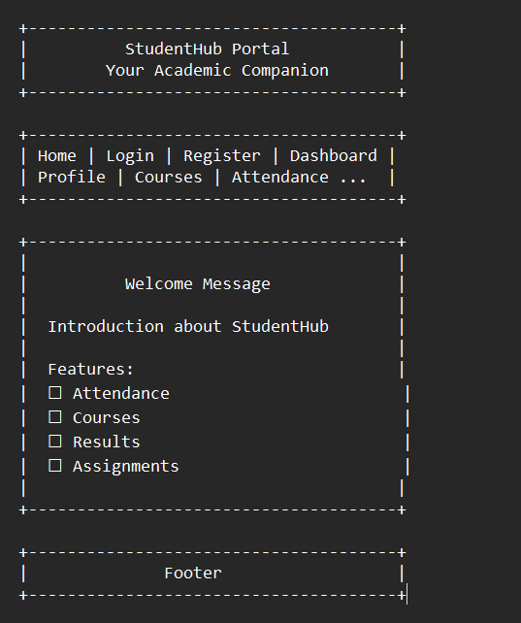

Purpose:
Introduction page of StudentHub portal.

PAGE 2: LOGIN PAGE (login.html)
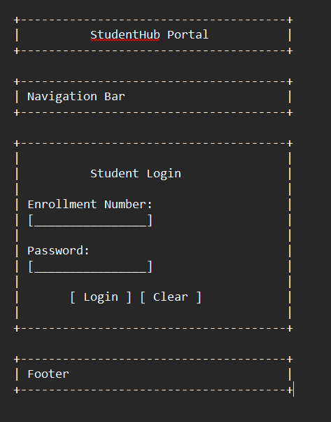

Purpose:
Student authentication.

PAGE 3: REGISTER PAGE (register.html)

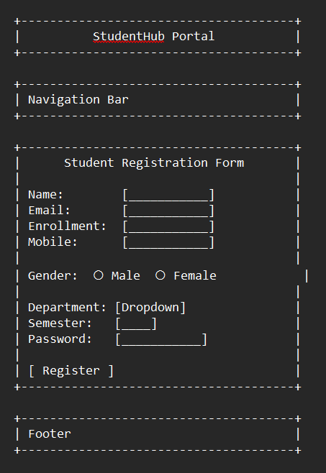

Purpose:
New student registration.

PAGE 4: DASHBOARD PAGE (dashboard.html)
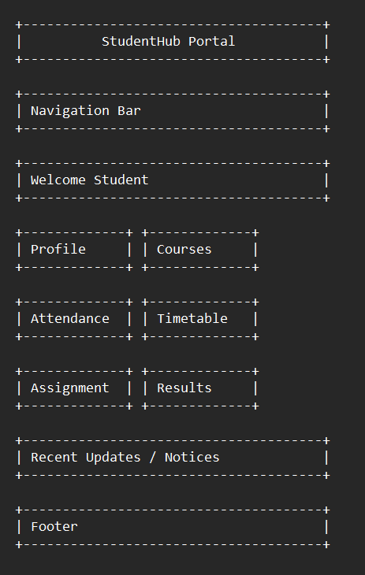

Purpose:
Main student control panel.

PAGE 5: PROFILE PAGE (profile.html)
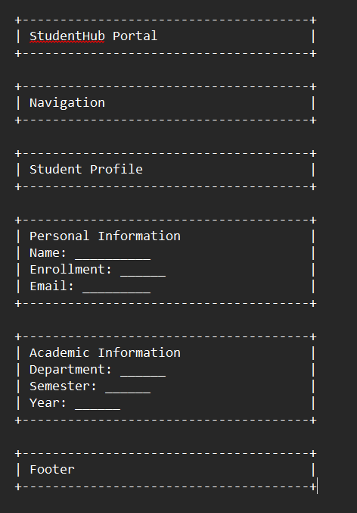

Purpose:
Display student details.

PAGE 6: COURSES PAGE (courses.html)
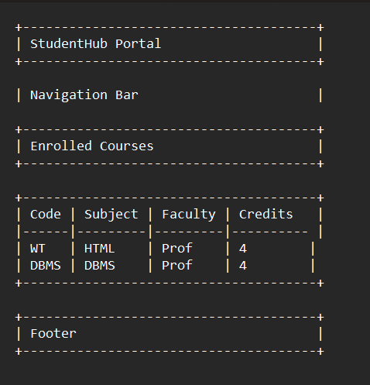

PAGE 7: ATTENDANCE PAGE (attendance.html)
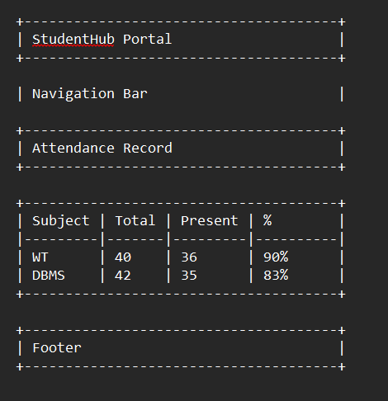

PAGE 8: TIMETABLE PAGE (timetable.html)
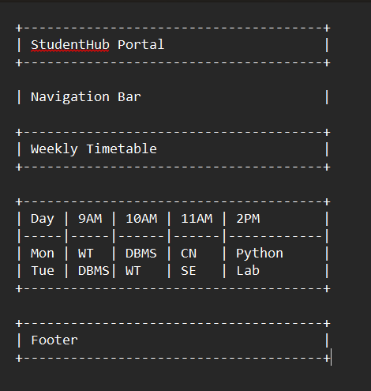

PAGE 9: ASSIGNMENTS PAGE (assignments.html)
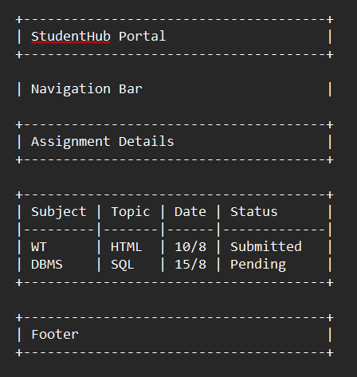

PAGE 10: RESULTS PAGE (results.html)
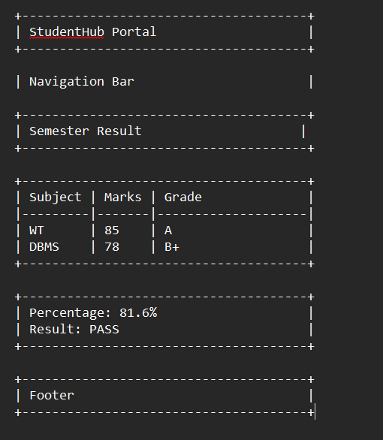

PAGE 11: NOTICES PAGE (notices.html)
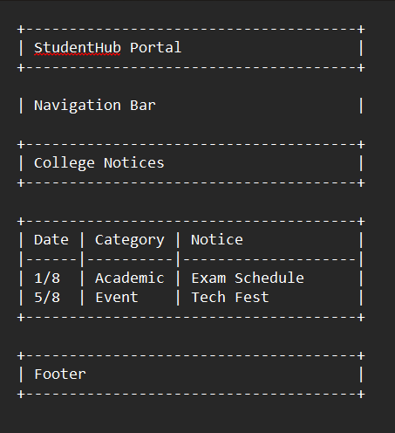

PAGE 12: CONTACT PAGE (contact.html)
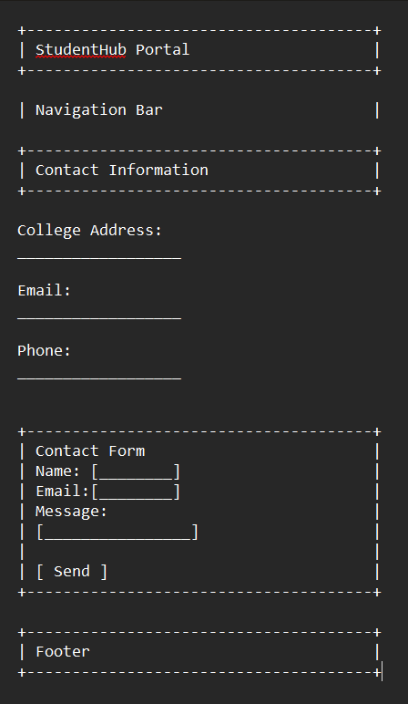

Conclusion
In this practical, the initial planning phase of the StudentHub Portal website was completed successfully. The project requirements were identified, a sitemap was prepared to define the website structure, and low-fidelity wireframes were designed for each webpage to visualize the layout and navigation. These planning activities provide a clear blueprint for the website and help ensure an organized, user-friendly, and efficient development process. This practical also highlights the importance of proper planning before starting the actual implementation of a web application.

